1.0 Scope |  |  |  |  |  |  | 2.0 Resource Required
- Purpose: To establish a consistent and reliable procedure for the scheduled collection of glass samples and dimensional verification using a vernier caliper  1.2 Area of Application: Applicable to all glass inspection areas including annealing, cutting, and dispatch.  1.3 Responsibility: - Operator/Inspector, Shift In-charge / Supervisor |  |  |  |  |  |  | 2.1 Man: Trained operator or quality inspector.  2.2 Machine: Digital Vernier Caliper (calibrated)  2.3 Material: Glass sheet, lint-free cloth, measurement table
3.0 Terms and Definition |  |  |  |  |  |  | 4.0 Key Performance Requirements
3.1 Digital Vernier Caliper – A precision measuring instrument used to measure dimensions. |  |  |  |  |  |  | 4.1 Quality: - Vernier caliper must be calibrated, and readings must be recorded accurately. Samples must be representative of the production run and free from handling damage (e.g., chips, scratches).  - EHS: No cut injury,
5.0 Frequency |  |  |  |  |  |  | 6.0 Competency Enhancement
5.1 Measurement to be taken for every production batch or as per inspection plan. |  |  |  |  |  |  | 6.1 Operators must undergo periodic training for handling digital vernier calipers.
7.0 Procedure
7.1 Sequence of Operation

7.1.1 Sample Collection from Running Production  Daily Sample Collection:  - At the start of each production shift, confirm the current running product size and type  - Safely retrieve one complete set of glass samples (left and right piece for two-piece cutting, or one single piece for single piece cutting) for the running size  - Mark the sample(s) immediately with Shift, Date, Time, and Line using marker.  Weekly Sample Collection:  - Confirm the production batch or run for the weekly quality check.  - Safely retrieve a total of ten (10) continues glass from the production run over the designated period (e.g., end of the week).  - Immediately place the collected 10 pieces onto a glass storage rack to prevent damage and contamination until measurement. |  |  |  |  | 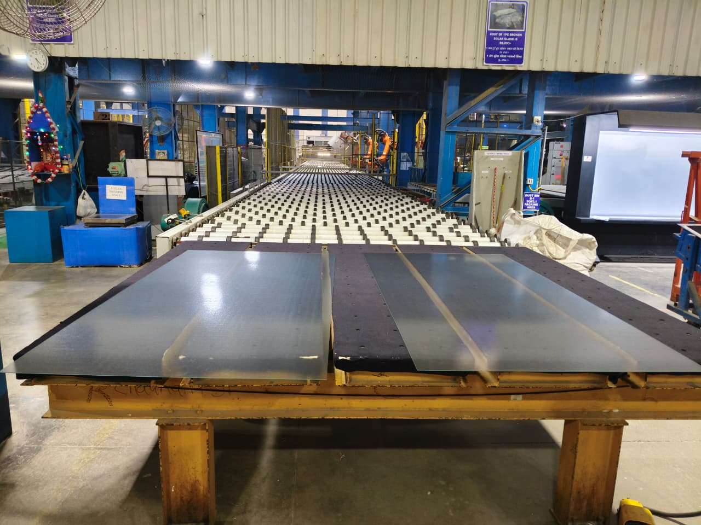  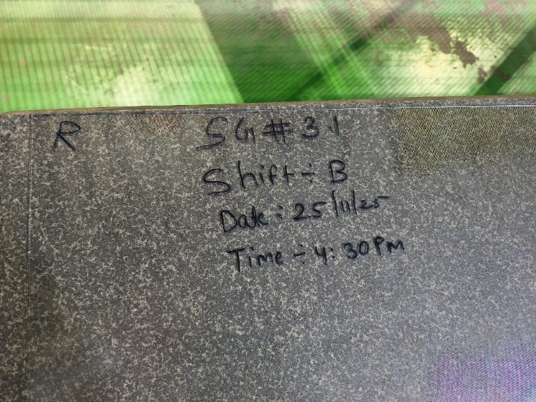
7.1.2 Sample Transfer and Setup:  - Carefully shift the collected daily sample set(s) or the weekly samples from the production line/rack to the Flatness or Measurement table  Note: Ensure the Measurement Table surface is clean, dry, and free of any debris that could scratch the glass or compromise measurement accuracy. |  |  |  |  | 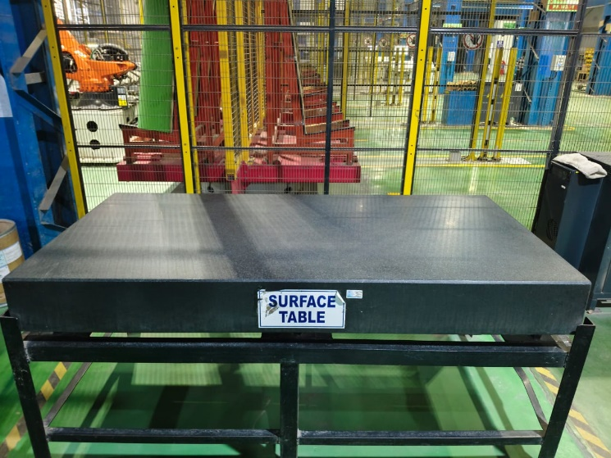
7.1.3 Take the vernier caliper out of its protective case and place it gently over the clean measurement table.  *Verify the calibration status (check the sticker/log). DO NOT USE it if the calibration date expires. |  |  |  |  | 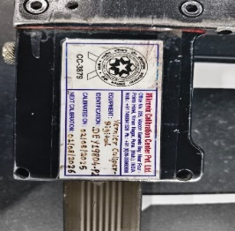
7.1.4 Zero Setting - Gently close the jaws of the caliper and press the ZERO. |  |  |  |  | 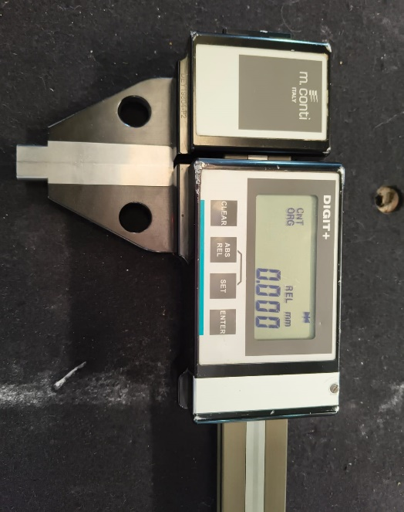
7.1.5 Measurement Procedure:  - Place the glass sheet flat on the clean measurement table.  - Open the caliper jaws wider than the dimension to be measured.  - Place one fixed jaw on the starting edge of the glass sheet.  - Extend the movable jaw to the opposite edge, ensuring the jaws are perpendicular to the edges and in full contact.  - Lock the slide and record the first Length (L1) reading from the display.  - Repeat the length measurement on the same piece at a different location (opposite side) and record the second Length (L2) reading.  - Rotate the glass (or calliper) 90°  - Repeat steps c) to e) to measure and record the first Width (W1) reading.  - Repeat the width measurement on the same piece at a Opposite side and record the second Width (W2) reading.  - Immediately transcribe all recorded L1, L2, W1, and W2 readings, along with the sample identification details, onto the Log Sheet. |  |  |  |  | 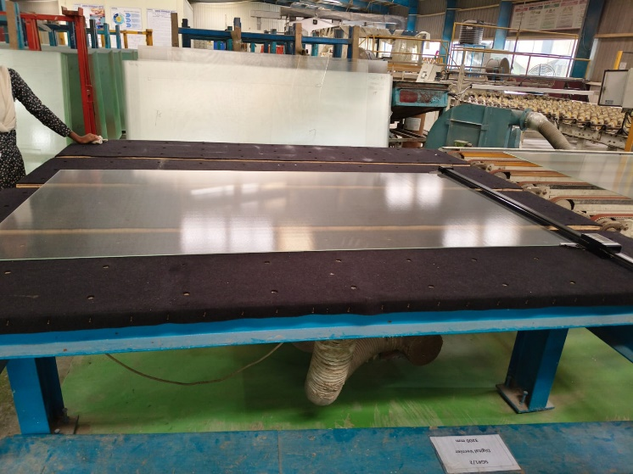  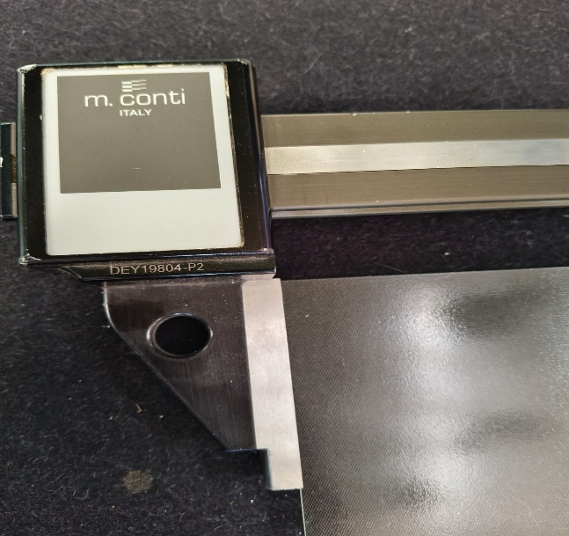  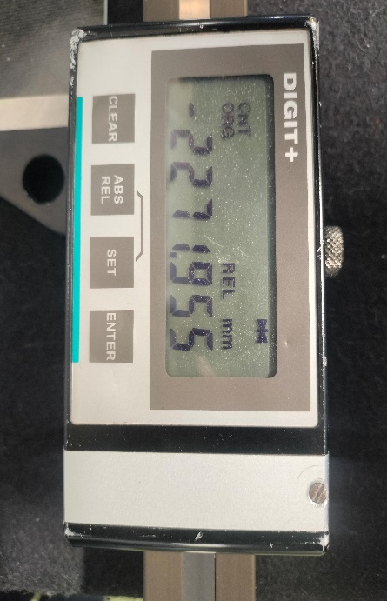  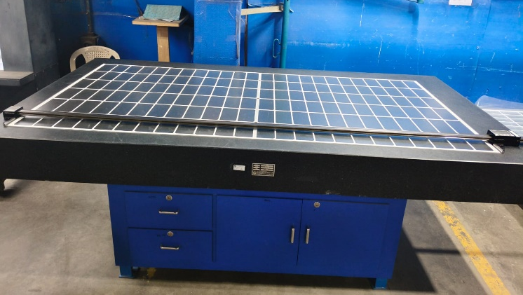  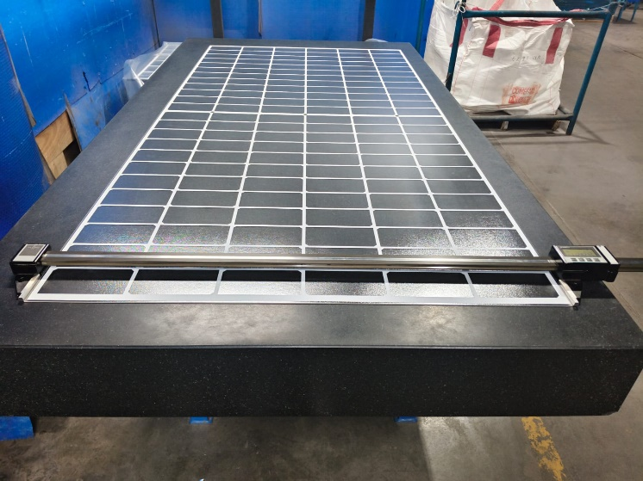  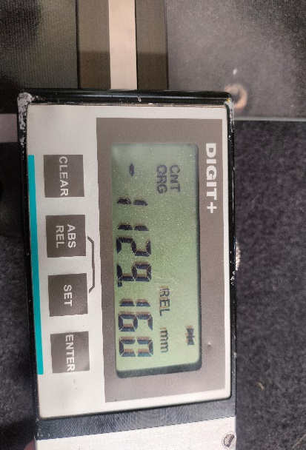
7.2 Special Process Requirements
7.2.1 The measurement location on the glass sample for both length and width must be at least 10 mm (or as specified) away from the edge to avoid any edge effects or micro-chips influencing the reading.
7.3 Prevention & Detection Controls
7.3.1 Verify ZERO before measurements.
7.3.2 Periodically check caliper battery level.
7.4 Controls Related to EHS
7.4.1 PPE MATRIX
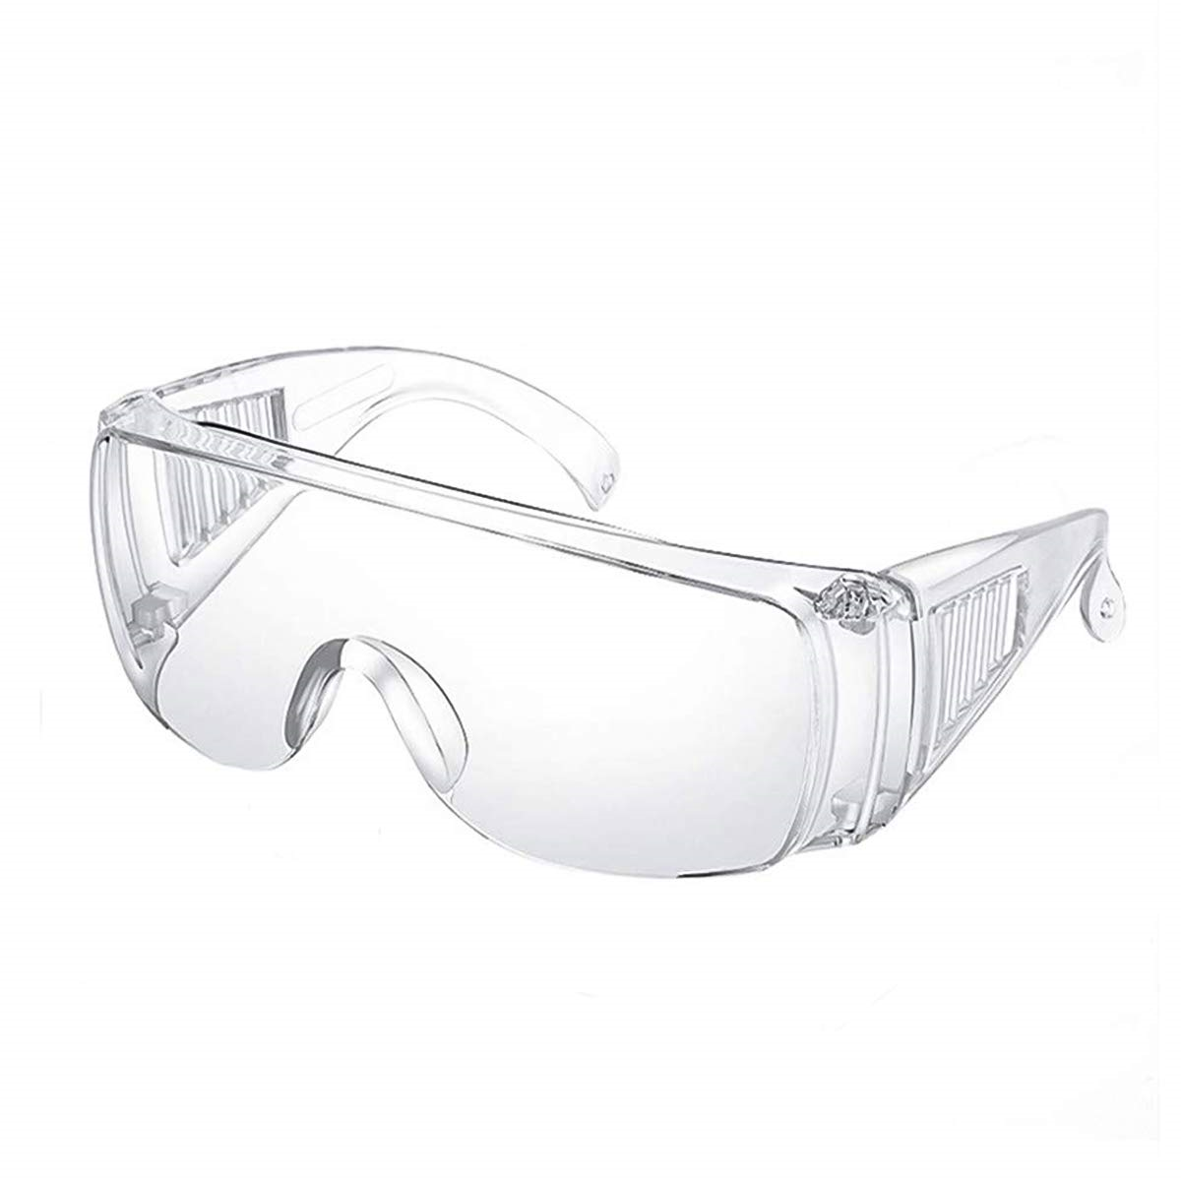 |  | 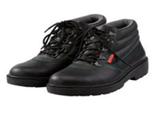 |  | 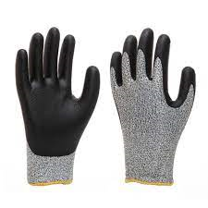 |  |  |  | 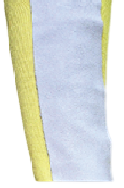 | 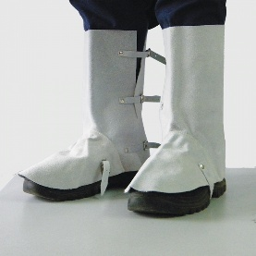
Hand gloves |  | Goggles |  | Safety shoes |  |  |  | Arm Guard | Leg Guard
7.4.2 NA

8.0 EHS Compliance Obligations
8.1 Follow applicable workplace safety guidelines related to handling glass and sharp tools.
8.2 Broken or rejected glass must be disposed of immediately in designated, clearly labeled cullet containers only.

9.0 Possible deviation & Impacts |  |  |  |  |  | 10. Proposed actions
9.1 Caliper Not Zeroed Correctly - Inaccurate dimensions are recorded, potentially leading to false acceptance of out-of-spec product or false rejection of good product.  9.2 Glass fall and break white handling – Injury to person |  |  |  |  |  | 10.1 Immediately re-zero the caliper and re-measure the entire sample. If zeroing fails, tag the caliper as 'Out-of-Service' and notify the supervisor.  10.2 Refresher training for all glass handling people over the period.
11. Reference documented information
11.1 Annealed inspection logbook – QA/L4/006
12. Revision History
Revision No. | Date |  | Description of changes
00 | 21.11.2025 |  | Initial release

